**Group Project: Building an Ambient Display**

**Naina Jain & Alan Lambie**

1. **A description of the display, including pictures**

*Athing2do* is an ambient display with the objective to remind daily high-level activities. For example sport, family, school, social and entertainment. Although the solution is oriented to solve the classic problems that parents experience forgetting their child activities, this solution is also easy configurable for multiple purposes in the context of remembering activities. The input is provided by a web-base calendar where the user defines the representation of the activities (link between digital and physical definition). The web-base calendar communicates the daily information to the physical display and this represent the information in a visual form. In this model each butterfly represent an activity and the flower in the center of the display represents the status of the information (Figure 1). The aesthetic of the display blend perfectly with other ornaments around the house and children rooms (Figure 2).

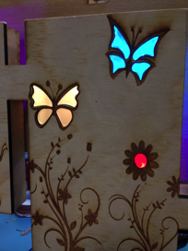

Figure 1. Colors represent status of the activity. In this case two activities are due this day and the system has been updated as the flower

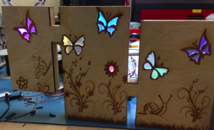

Figure 2. The design was created to blend with the environment (rooms in the house) as another ornament on the top of a table or hanging on the wall.

Building Process and Testing

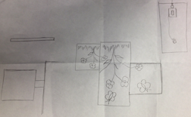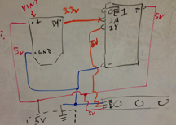

Designing the circuit

Sketching a solution

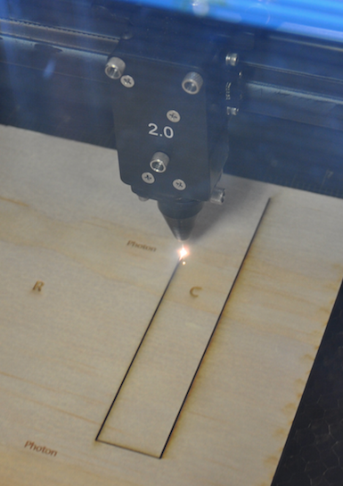

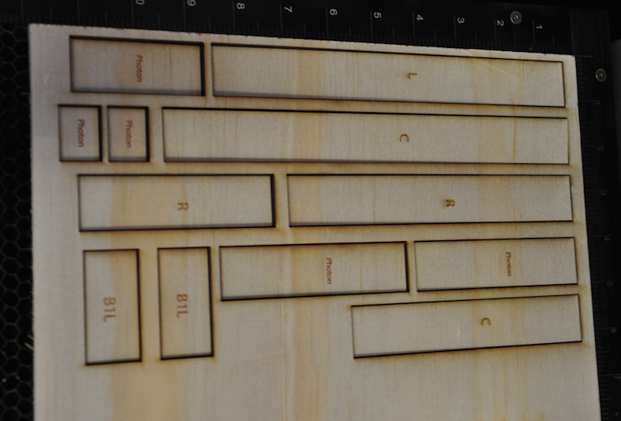

Each piece with an identification to avoid mistakes in the assembly task

Using wood and a Laser cutter to cut each piece of the design.

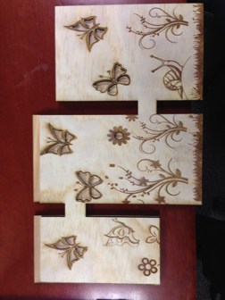

Front cover laser cut and raster showing the design.

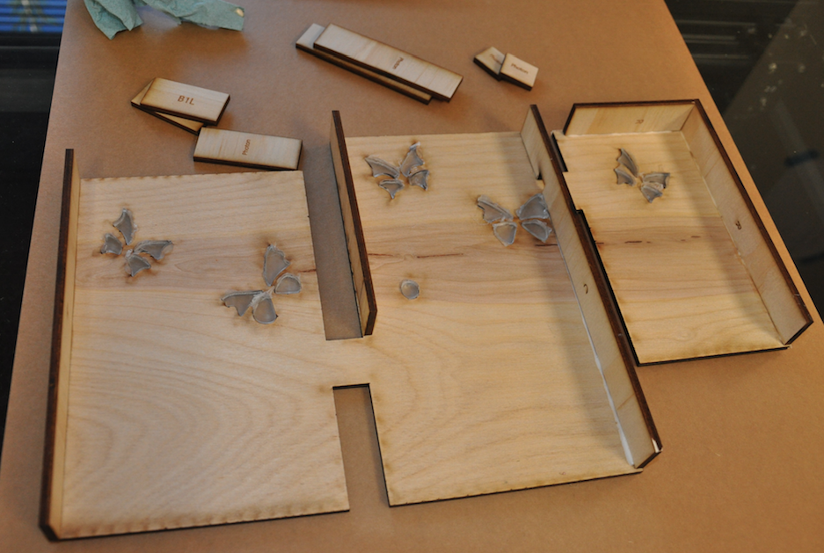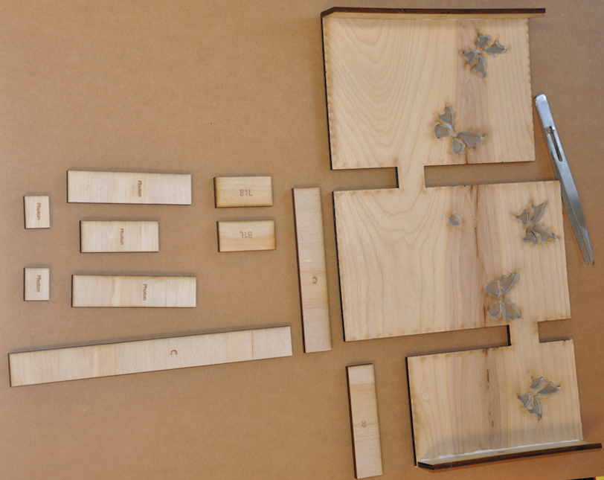

Assembly the frame of the display

Starting the process of assembly each piece of the design

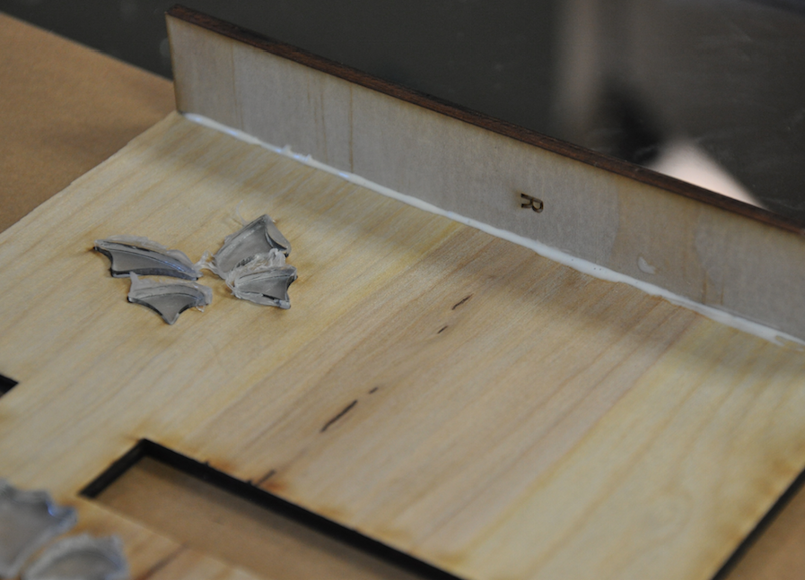

Wall attached with glue



(a) (b) (c) (d)

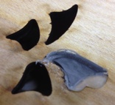

Sequence of acrylic parts assembly. (a) Using silicone to stick a piece of acrylic. (b) One butterfly with all the acrylic pieces (back view). (c) One butterfly with all the acrylic pieces showing the rastering area (front view). (d) One butterfly illuminated from behind (front view).

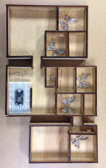

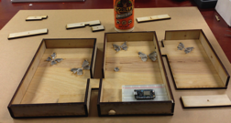

Assembly the internal divisions to provide a constraint area for illumination

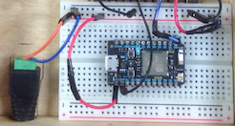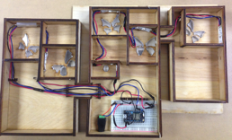

Incorporating the circuit

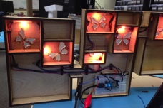

Testing color sequences.

Testing the wiring task. Providing power to the photon and Neopixel array.

1. **What choices you made for the information to display and the way you displayed it, justification for your design based on previous research.**

**Previous research as Justification for decision in design**

We used the heuristics for ambient displays evaluation (Mankoff et al, 2003) to justify the decision for the design.

1. Useful and relevant information

In the intended setting

We believe this display presents the right amount of information to allow the user understand the message (at a high level) and react accordingly to it. As a result, the display is useful for the intended purposes and the information is relevant only for the user.

1. Peripherally of the display

The display should be unobtrusive and remain so unless it requires the user’s attention. User should be able to easily monitor the display.

1. Match between design of ambient display and environments

One should notice an ambient display because of a change in the data it is presenting and not because its design clashes with its environment.

The design and aesthetic of this display make it blends perfectly in many of the environments for which this display has been designed (Living rooms, family rooms and bedrooms). The information rendered is in the form of color illuminating areas of the display. The frequency of information change is low so the display is very stable in terms of visual representation and saliency (it doesn’t attract the attention so much at least the user need to use the information).

1. Sufficient information design

The display should be designed to convey ”just enough” information. Too much information cramps the display, and too little makes the display less useful.

The information displayed is a high level. It means the user will use that information only to remember a certain class of activity. For most of the cases the assumption is that the user will trigger the memory of the specific activity only remembering the high level class of that activity. For example, if the display remind the user that today are sport activities, the user will be able to remember if the specific activity is swimming or soccer.

1. Consistent and intuitive mapping

Ambient displays should add minimal cognitive load. Cognitive load may be higher when users must remember what states or changes in the display mean. The display should be intuitive.

The level of cognitive load will be related with the learning curve for this display. The identification of each activity associated with a color will be a moderated level of cognitive load at the beginning but very soon that level will decrease considerably.

1. Easy transition to more in-depth information

If the display offers multi-leveled information, the display should make it easy and quick for users to find out more detailed information.

As mentioned before, the display objective is to remind the user high level of activities. In the case the user doesn’t remember the specific activity, the user will have to access the actual calendar or schedule.

1. Visibility of state

An ambient display should make the states of the system noticeable. The transition from one state to another should be easily perceptible.

The combination of different states of each activity is limited to a couple of instances. The basic configuration is binary (there is activity or not). The user will recognize change on those states very easily (no activity = neutral or absence of color and activity = color).